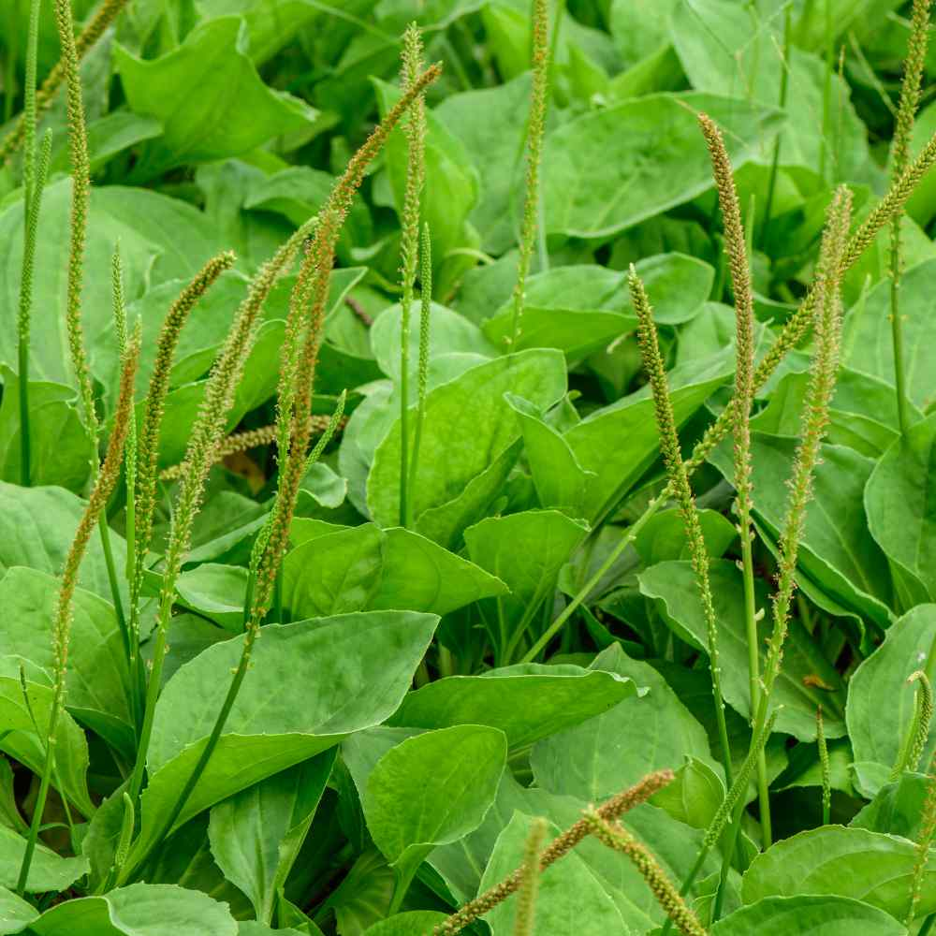

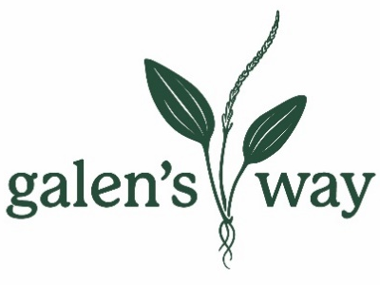

Sustainability Report 2021

Sustainability
/səˌstānəˈbilədē/
noun
avoidance of the depletion of natural resources in order to maintain an ecological balance.
the ability to be maintained at a certain rate or level.
"the pursuit of global environmental sustainability" & "the sustainability of economic growth"

Table of Contents
Overview and Mission  Certifications  Summary of 2021 | Sustainability  Of  Resources  Waste  Energy  Water | Sustainability  Of  Practices  Sourcing  Producing  Shipping | Sustainability  Of  People  Employees  Community

Galen’s Way Botanicals is a small herbal business with a desire to do right in the world. Galen’s Way was birthed out of a yurt through a quest to made medicine from plants more available to the people. Since the first transaction, Galen’s Way has been devout to its’ values. While profit must be part of a thriving business, it has never been considered the most important aspect of success. Quality and purposeful practices have always been the Galen’s Way.

Our Mission
Our mission is to provide the highest quality herbal extracts to the practitioner and clinic market while embodying practices of a community-oriented business.
We are committed to donating 1% of profits tracked by 1% for the Planet, organic purchasing when available, quarterly hours of time given to community volunteer work, and maintaining our green business certification and organic product certifications.

The question arises ‘how do we run a successful business without depleting our environment?’
Our answer is ‘we are trying’.
We choose to act responsibly in every decision we make. We strive to continually improve our practices. We make a point to talk about the impact of our challenges and successes. We analyze our performance and our dedication to our commitments on a regular basis in order to hold ourselves accountable.

Certifications
Galen’s Way became a certified California Green Business in 2021. | We have been certified with California Certification of Organic Farmers since 2009. | EverGreen has been our energy provider since 2021. They provide 100% renewable, low-impact energy. | A majority of our shipments go out of the building with the Carbon Neutral Shipment program from UPS where the impact of shipping is offset with carbon credits. | Many of our products are certified with the USDA Organic logo signaling all organic ingredients were used in them.

We have been actively working towards becoming a certified B corporation with B Corp since 2019. It has been a long-standing goal of Galen’s Way to achieve the B Corp certification status. B corporations demonstrate leadership in using business as a positive force in the world.

Summary of 2021

Achievements
- Activated our volunteer program this year and will continue to volunteer as a team quarterly.
- Established and met our commitment with 1% for the Planet to donate 1% of our profits annually to mission-based organizations.
- Committed to donating $6000 a year of in-kind donations to the Botanical Bus, a bilingual mobile herb clinic.
- Used Sonoma Clean Power’s Evergreen program to purchase 100% local, renewable, and low-impact energy generation services for the entire year.
- Became certified as a California Green Business.
- Reduced waste and packaging in the Quality Control department by sanitizing and making certain things in-house.
Focus
- Develop a system to quantify and analyze our waste stream
- Find alternative methods to dispose of aspects of our waste stream that are not recyclable, compostable, reusable
- Get employees involved in donation programs
- Work towards our B Corp certification

Sustainability of Resources

WASTE
The waste stream at Galen’s Way has been under scrutiny since day 1. Every item of waste is considered in our manufacturing process and we are always striving to improve upon new avenues of reduction. Our waste stream involves four primary areas – Compost, Green Waste, Recycling, and Landfill. In addition to our municipal solid waste, we have general toxic waste like batteries and electronics as well as bio-hazardous waste from our on-site microbiology lab.

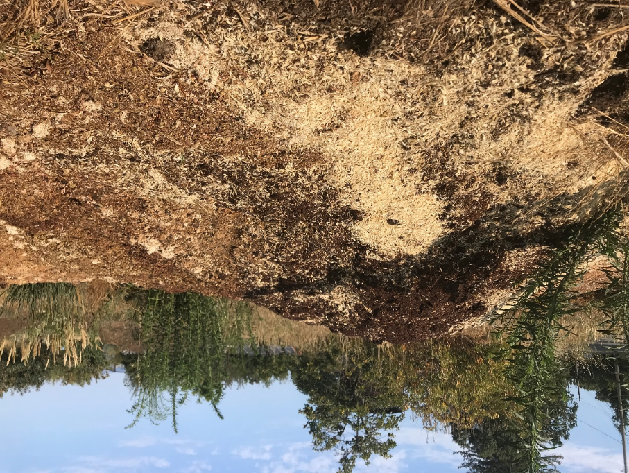
Compost
All our marc, or spent herb material after pressing, is composted at a local farm. This farm has been growing organic vegetables for a CSA with our compost for over a decade.

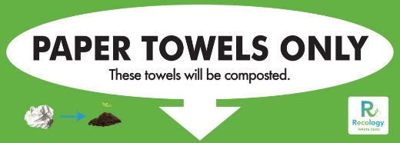
Green Waste
All our paper towels are collected and disposed of in the green waste bin that is collected and processed at a local compost facility.

Recycling
We recycle paper, cardboard, glass, and plastic in our weekly recycling bin. We also take our plastic bags to be recycled separately. We have started using Terracycle to recycle some of our more challenging waste items like plastic caps, gloves, hairnets, and label backing.
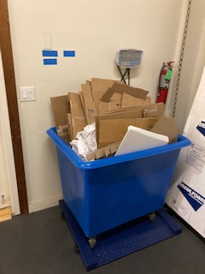
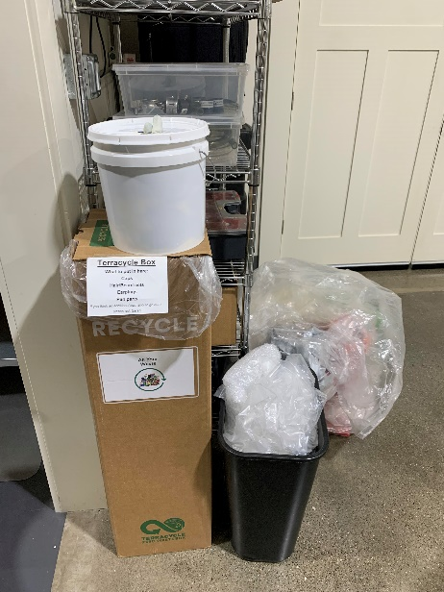

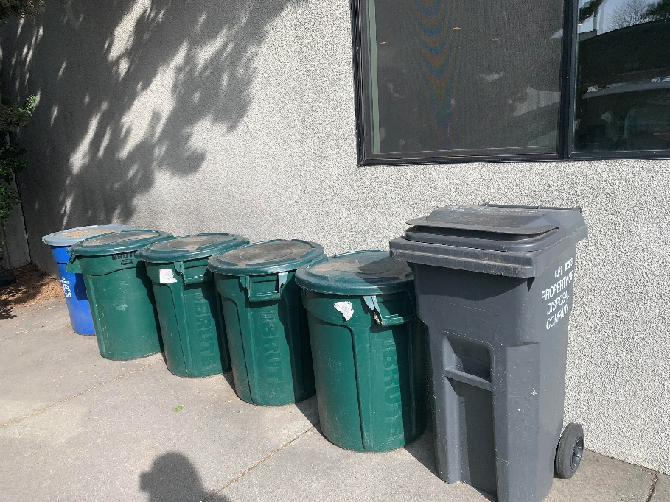
Landfill
ONLY 32 GALLONS! Rarely full each week
COMPOST
The smallest waste bin we have is our garbage bin and it’s typically not full every week. We do everything we can to keep waste from ending up in the landfill.

Bio-Hazardous Waste
The waste from our microbiology lab is considered bio-hazardous waste and is disposed of accordingly, never ending up in the landfill. We continually stive to reduce this waste by making more consumables in-house, sterilizing and refilling items where possible and opting for more recyclable materials.

Toxic Waste
One final aspect of our waste stream are items that are neither recyclable nor allowed in the landfill. While we minimize our use of batteries by using rechargeable batteries, we still have some batteries as well as electronic waste, paint, etc. that must be disposed of at required facilities.
Waste Reduction Accomplishments in 2021
- Switched to pdf instead of paper printing for Document Control
- QC practices amended to making TSB in-house with re-usable autoclavable glass bottles instead of ordering TSB in single use plastic. Package reduction was also achieved by buying tips in bulk and refilling plastic holder instead of buying pre-filled plastic holder.

Sustainability of Resources
ENERGY
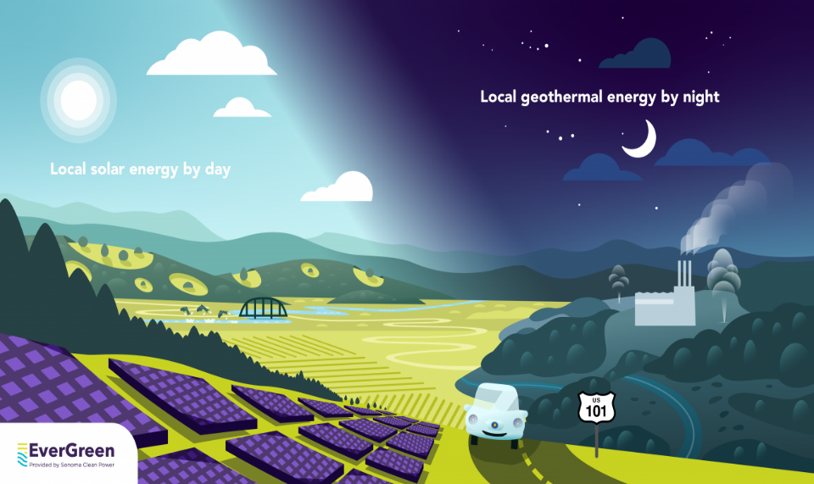
Electricity
We are fortunate to have access to 100% clean and renewable energy at our facility. We enrolled in the Sonoma Clean Power program in 2019 which provided approximately 49% renewable electricity generation and 91% carbon-free energy generation. In 2021, we expanded our commitment by enrolling in the Evergreen program through Sonoma Clean Power where all our electricity is generated locally and renewably with solar and geothermal operations.
We offset 100% of our greenhouse gas emissions with carbon credits.

Energy Efficiencies
All of our appliances are Energy Star certified.
All of our monitors are set to auto sleep mode.
Our facility has sky lights to provide natural light which are covered for temperature control.
We use LED lighting.
Occupancy sensors are installed in the bathrooms and macerating rooms.
Our HVAC has a programmable thermostat.
Our office has double-paned windows and a glass door installed to assist with temperature control.
WATER
We design our business practices to conserve and minimize water usage. We use low-flow faucets and toilets. As a tenant in a shared warehouse building, we do what we can to minimize our water impact but do not have the ability to track or monitor our usage.
Our efforts include:
- Hands-free sink to reduce water usage
- Non-regulation water flow rate on all plumbing in production

Sustainability of Practices
SOURCING
Responsibly sourcing our ingredients and supplies is an important part of our commitment to sustainability. We are continually reviewing our vendor lists and the marketplace for more organic herb options. We buy what we can from local farms and support local businesses for as many of our expenses as possible. It is important to us to cultivate long-term relationships with our vendors.

Respecting the balance of market demand and plant populations is an inherent practice for us. We monitor endangered or threatened herbs and discontinue production of them when needed. In 2021, we discontinued Osha root due to the threatened wild populations and the inability to cultivate this herb.
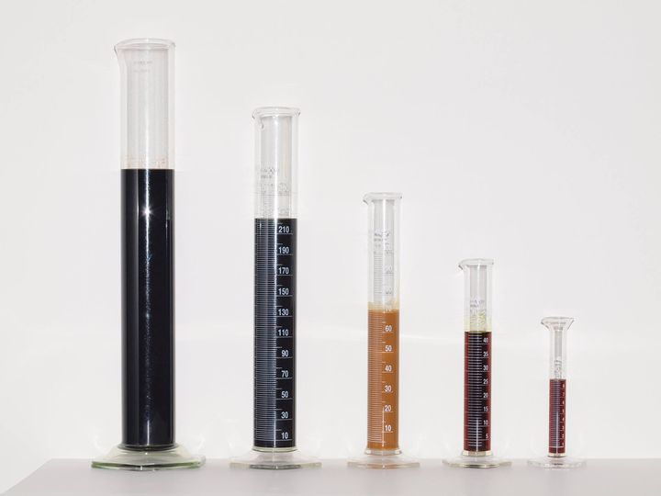
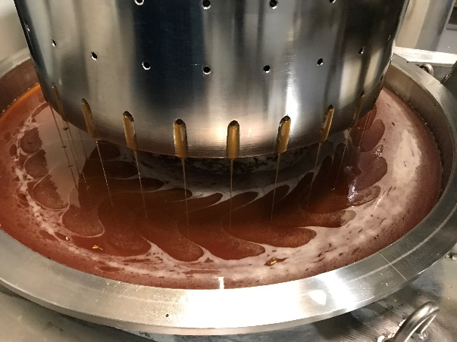
PRODUCING
All aspects of production are analyzed for efficiency and sustainability. Below are some of the considerations taken:

- compost spent marc (used herb material left over after pressing)
- bulk purchases to reduce packaging waste and shipping footprint
- recyclable packaging and labeling on majority of our products
- purchase of sanitizer liquid in bulk and refill at stations
- Unbleached/chlorine free paper products made with recycled content

Shipping with UPS’s Carbon neutral program
Using recycled packaging
Reusing other packaging material
Offering local pickup
One of the largest contributing factors to our carbon footprint is the transport of our products to our customers. We do what we can to minimize this impact including:
Packing with Compostable peanuts
Lowering Our Product Transport Carbon Foot Print
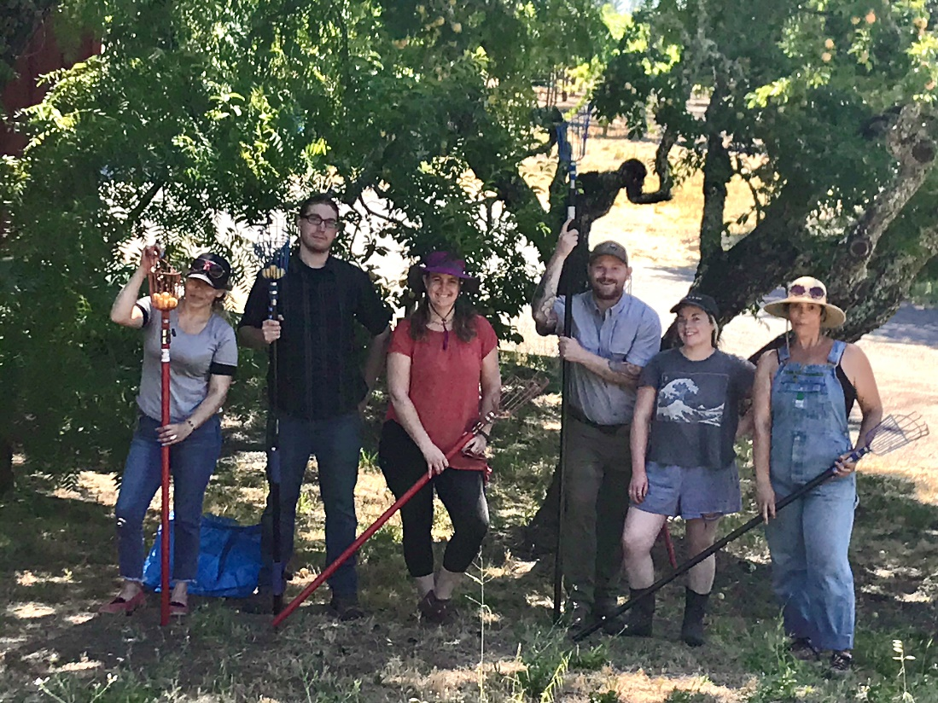
Sustainability Of People
Employees
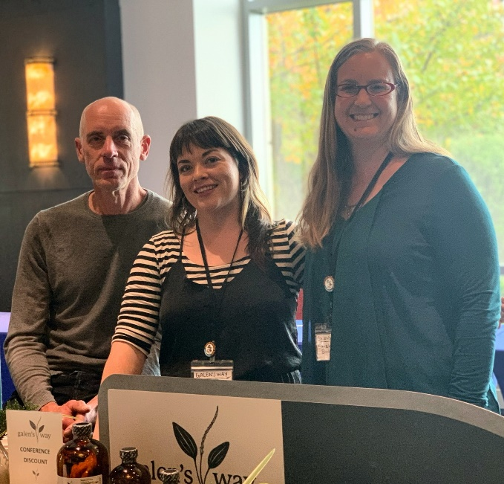
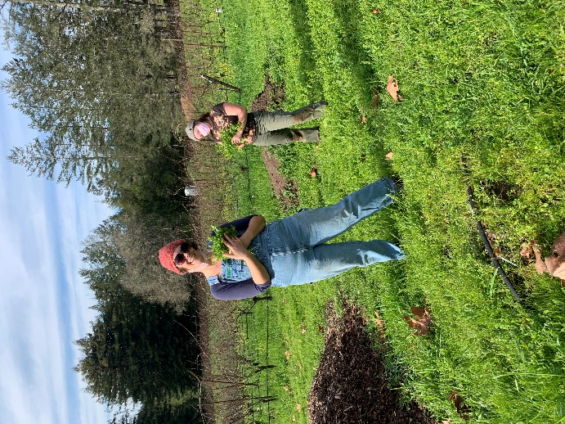
We understand that our employees are the backbone of our company and we value their quality of life both at work and beyond. Galen’s Way offers its employees flexibility, modified work schedules, and supports children joining the work day when needed. We encourage our employees to further develop skills by compensating continuing education opportunities. The staff also have access to our products on a monthly basis as part of a means to support health in the office culture.
In 2021, we began offering our employees a 401K retirement plan.

Community
Community involvement is at the core of Galen’s Way. Donating our products to meaningful causes and organizations enables us to support our community. Volunteering our time is an opportunity to make positive change in our community. Donating 1% of our profits to purposeful non-profits is a commitment we’ve made with 1% for the Planet.

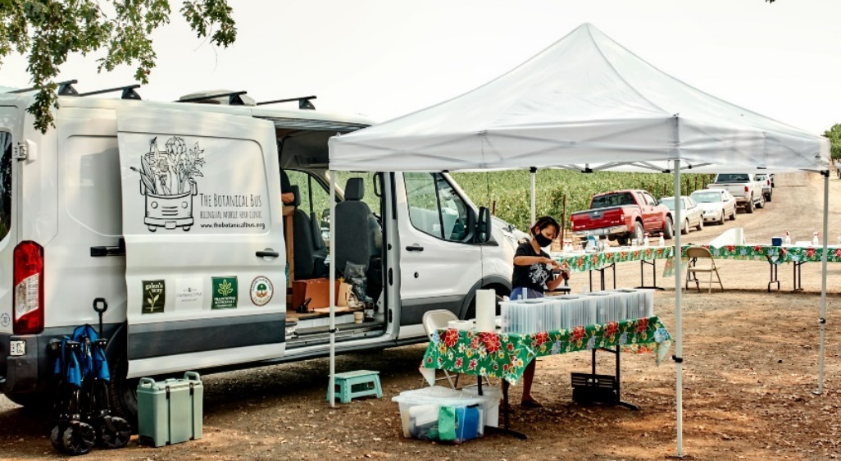

Donations
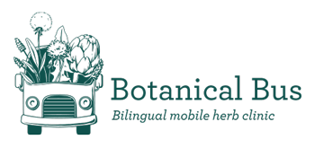
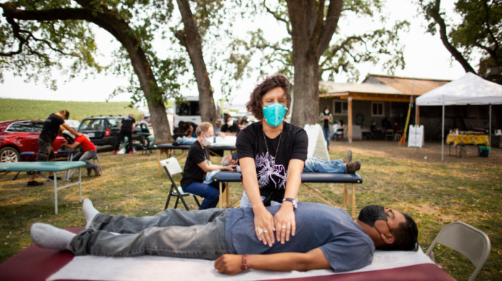
We love donating our products to organizations. In addition to our long-standing relationships with events or groups, we have an annual commitment to donate to the Botanical Bus, a bilingual mobile herbal clinic.

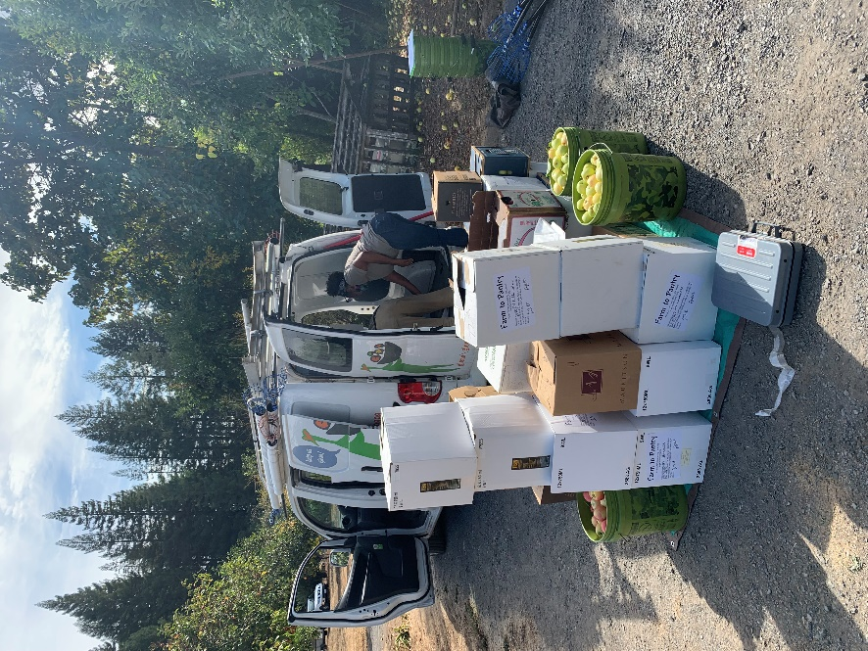
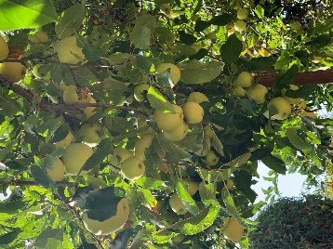
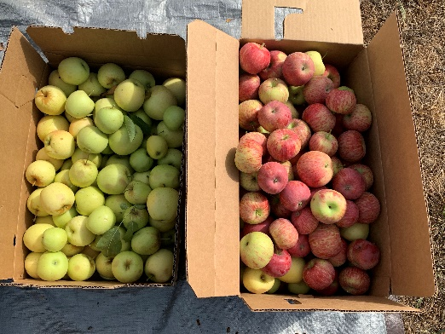
Volunteerism
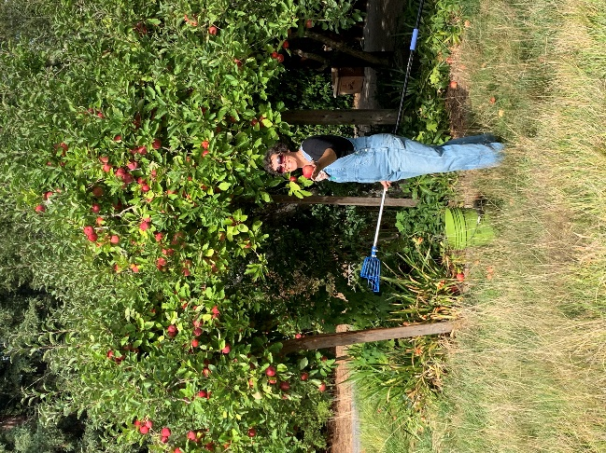
We want to interact with our community in ways that touch the daily lives of people, to bring a level of care and attention to helping those in need. Volunteering our work hours to the community on a quarterly basis allows us to meet our community and contribute to healthy living. Our first group volunteering program involved our team gleaning (harvesting food that would otherwise go to waste) of over 1000 lbs of apples that went to a local food bank.

Gleaning
/ˈɡliːnɪŋ/
verb
The simple act of collecting excess fresh foods from farms, gardens, farmers markets, grocers, restaurants, state/county fairs, or any other sources in order to provide it to those in need.

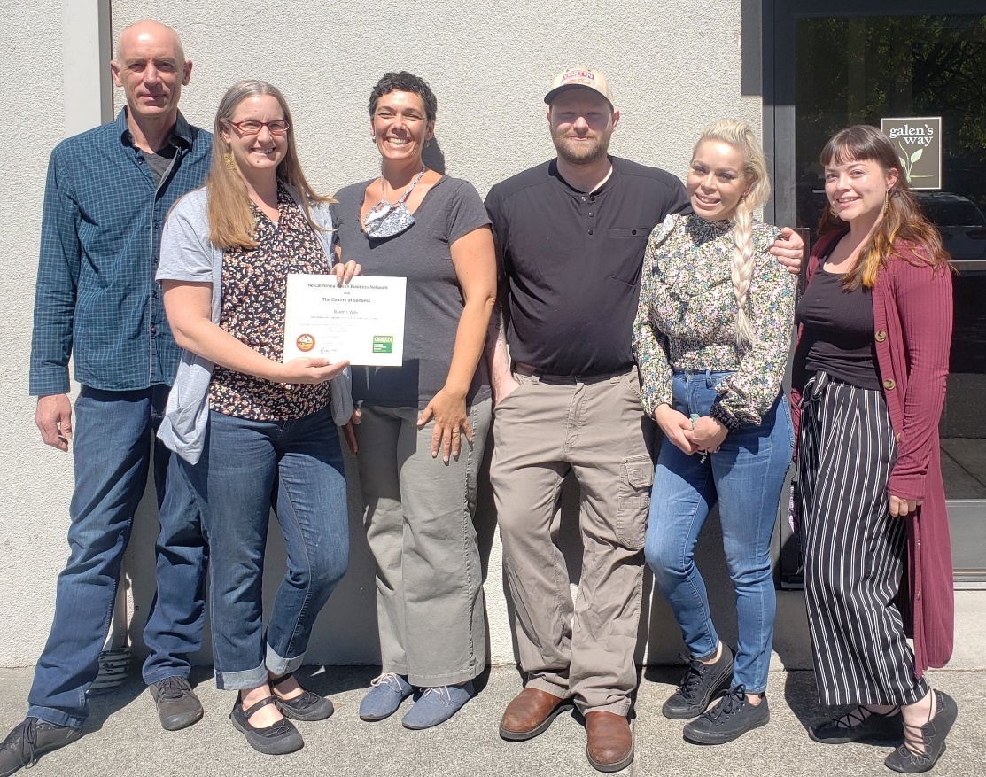
Galen’s Way is a small herbal business with a desire to do right in the world.
Since the first transaction, Galen’s Way has been devout to its’ values.
While profit must be part of a thriving business, it has never been considered the most important aspect of success.
Quality and purposeful practices have always been the Galen’s Way.

